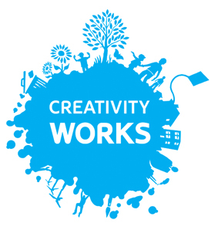

The Radstock Arts Project: Artists’ Application Form
Name:
Address:

Email:
Tel:

Have you worked with CW before or attended a co|Create session?

Please tell us about your relevant experience and work:

Please tell us your proposal for the Radstock Arts Project, including the age, type of group and length of project:

What do you consider would be the key challenges of your proposal?

Would you like to be added to our newsletter
Yes No I am already signed up
Please email your proposals to oliver@creativityworks by 10am on Monday 10th October

